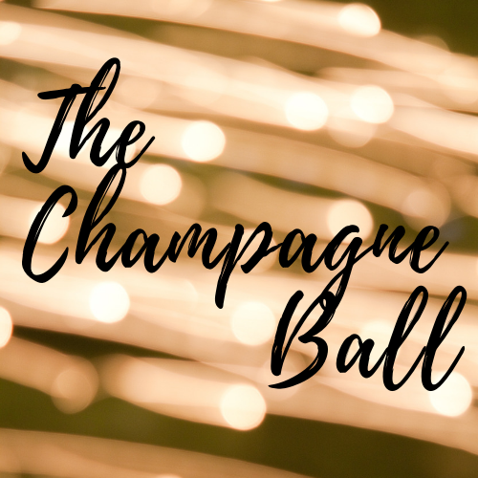

About Toby’s Shower for Babies
Toby’s Shower for Babies is a nonprofit designed to support NICU (neonatal intensive care unit) families. The NICU is where premature and newborn babies who need constant medical care and surveillance spend days, weeks, or months before they can go home (if they are blessed enough to make it home). Most families aren’t expecting to go to the NICU and don’t get time to prepare anything, which can be very rough on the family.

This project creates a basket of baby items for an incoming NICU family. The basket contains a tie fleece blanket for baby’s isolette, swaddling blankets, a stuffed animal, a couple of books for parents to read to baby, and a picture frame for the parents, among other things. The project also provides parent support in the form of a mentorship program called, “A Shoulder To Lean On.”

While parents don’t get to take their babies home right away, these baskets can help their hospital rooms feel less sterile and warmer and more inviting, while they undergo for their precious little fighter. Our goal is to increase parental involvement with their child in the NICU. This helps with bonding between parent and child while delivering hope in a frightening situation. Everything in these baskets belongs to the family to keep for years to come!

Help Toby’s Shower for Babies spread some love to other NICU families and their babies!
About the Champagne Ball

The Champagne Ball is Toby’s Shower for Babies annual formal event to help raise awareness about the organization as well as funds to increase the number of baskets and other support programs we can deliver to NICU families.

This event will be held on Saturday, May 25th, 2019 from 6p-10pm at The Loft in the Ellie Caulkins Opera House We expect 225-250 attendees this year. Further event details to follow.

WHY Support Toby’s Shower for Babies
Denver and Wyoming NICUs care for almost 2500 babies and families every year.

The CDC reports that 1 in 9 babies born will see NICU time.

Toby’s Shower for babies supports four Denver hospitals and two Wyoming hospitals.

Movers and shakers from all over Colorado and Wyoming are getting involved- don’t be left out!

We’re creating a community of support and inclusiveness. The NICU has no bounds and all walks of life are affected. Come be a part of a group of support, love and light!

Things we hear from parents:

“I currently have a baby in the NICU at Rocky Mtn Children's Hospital/St. Luke’s. My son was born in March. I just wanted to say how much we appreciate the basket that Brayton received. I've been meaning to write for a while, but it was such a nice surprise for me and my husband to walk into Brayton's room and see the basket. It made us so happy and nice to know that others cared so much about our little man! Thanks so much...what a blessing you guys are!”

“I just want to thank you for your donations to the NICU. My son has been there since June 20th and has a ways to go. We received a basket and were so filled with gratitude. Thank you again and would love to help when we get back home.”

Things we’ve learned from nurses in the NICU:

“Twins just came in yesterday and the mom is still in the hospital out of state. Seeing the baskets on Facetime made her instantly happy. She had been really worried and upset prior to that. Seeing them was very uplifting to her. She couldn’t wait to be there and use them in person. “

Champagne Ball Sponsorship Levels

Extra Brut Sponsor - $10,000
- Two 8 person tables (16 tickets) for The Champagne Ball
- Named Sponsor at secondary event of building and delivering a round of baskets to the Rocky Mountain Hospital for Children NICU or University of Colorado Children’s Hospital
- Exclusive front-page logo recognition on invitation
- Recognition at event by Emcee, event signage and printed materials
- Logo/name recognition on Toby’s Shower for Babies homepage and top level recognition on The Champagne Ball webpage
- Recognition in all publicity efforts including online media outlets and Colorado news media
- Free ad space on Toby’s Shower for Babies website for one year
- Podium speaking opportunity
- A bottle of Champagne for each table

Brut Sponsor - $7,500
- One 8 person table (8 tickets) for the Champagne Ball
- Recognition at event by Emcee, event signage and printed materials
- Logo/name recognition on The Champagne Ball webpage
- Recognition in all publicity efforts including online media outlets and Colorado news media
- Free ad space on Toby’s Shower for Babies homepage for six months
- A bottle of Champagne for the table

Extra Dry Sponsor - $1,500
- One 8 person table (8 tickets) for the Champagne Ball
- Logo/name recognition on The Champagne Ball webpage
- A bottle of Champagne for the table

We’d like to sponsor the Champagne Ball

Company Name:_____________________________________________________________

Contact Name and Title:_______________________________________________________

Company Address: ___________________________________________________________

City:____________________________State:_______________________Zip:_______

Contact Phone: ______________________________________________________________

Contact Email:_______________________________________________________________

Make checks payable to Team Toby Tolin.
Team Toby Tolin is a 501(c)(3) tax-exempt charity; EIN: 47-0971399.

Team Toby Tolin
Elizabeth A. Tolin, Founder
6509 Horse Soldier Rd
Cheyenne Wy 82001
307-256-7403

